AMAM

Use-Case Specification

Version 1.0

*[Note: The following template is provided for use with the Rational Unified Process. Text enclosed in square brackets and displayed in blue italics (style=InfoBlue) is included to provide guidance to the author and should be deleted before publishing the document. A paragraph entered following this style will automatically be set to normal (style=Body Text).]*

*[To customize auto*

*matic fields in Microsoft Word (which display a gray background when selected), select File>Properties and replace the Title, Subject and Company fields with the appropriate information for this document. After closing the dialog, automatic fields may be updated throughout the document by selecting Edit>Select All (or Ctrl-A) and pressing F9, or simply click on the field and press F9. This must be done separately for Headers and Footers. Alt-F9 will toggle between displaying the field names and the field contents. See Word help for more information on working with fields.]*

Revision History

| **Date** | **Version** | **Description** | **Author** |
| --- | --- | --- | --- |
| 23/11/2022 | 1.0 | First version | Từ Khai Hoài, Lâm Hiền Toàn, Nguyễn Việt Hùng, Thái Võ Đức Trọng, Nguyễn Đình Quốc |
|  |  |  |  |
|  |  |  |  |
|  |  |  |  |

Table of Contents

**1. Use-case Model** **4**

**2. Use-case Specifications** **4**

2.1 Use-case: Search a question 4

2.2 Use-case: View question detail 5

2.3 Use-case: Sign up 5

2.4 Use-case: Login 6

2.5 Use-case: Create a question 6

2.6 Use-case: View a profile 7

2.7 Use-case: Edit profile 7

2.8 Use-case: Answer the question 7

# Use-case Model

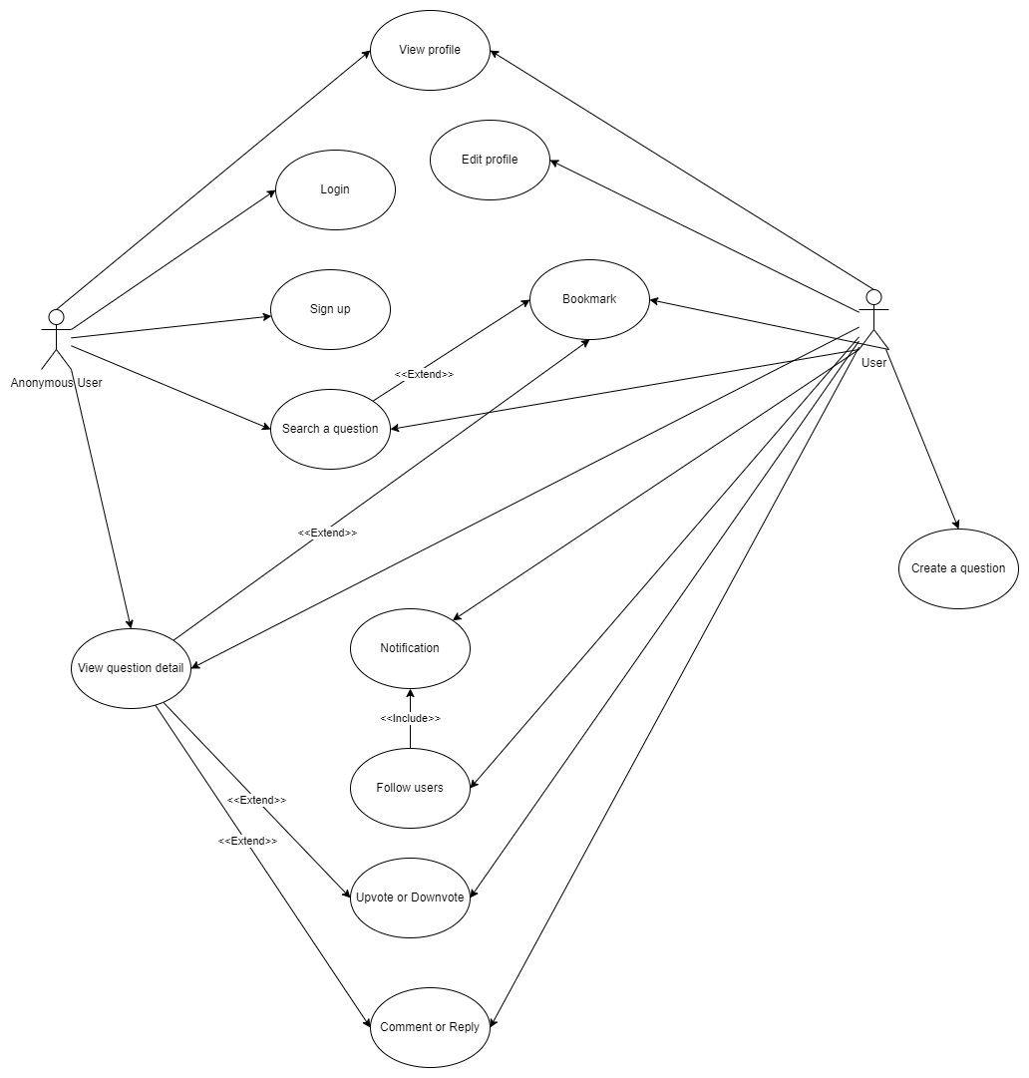

# Use-case Specifications

## Use-case: Search a question

| Use case Name | Search a question |
| --- | --- |
| Brief description | This use case describes how the Customer can search a specific question and see the list of questions as the result of the search operation. |
| Actors | Customer |
| Basic Flow | 1. At the homepage, the user enters keywords on the ‘Search’ field to search the questions 2. User can click to choose the filter mode to filter the result 3. Users clicks on ‘Search’ button to start searching a product 4. User go through the top to bottom to see the wished question 5. User can upvote or downvote the question before viewing the question’s detail |
| Alternative Flows | **Alternative flow 1: User is in the anonymous mode, meaning that he can not upvote or downvote.**  The search operation will be terminated at #5 in the basic flow. |
| Pre-conditions | User has to access the homepage of the web |
| Post-conditions | The user successfully searches the question and is going to view the question. |

## Use-case: View question detail

| Use case Name | View question detail |
| --- | --- |
| Brief description | This use case describes how the User views the detail of a question they |
| Actors | Customer |
| Basic Flow | 1. Users choose one question from the list of questions in home page or result page 2. System shows the detail of the question, including title, metadata, description 3. Users will go through from top to bottom and search for the answer in the comment section 4. Users can also leave a comment to show their thoughts or reply to someone |
| Alternative Flows | **Alternative flow: User cannot comment/reply, bookmark**   1. Users have to sign up first to become an official user 2. Go back to the question they’re care about and now they can comment |
| Pre-conditions | Users have to access the home page or search for a question in search bar, category |
| Post-conditions | Users finally get the answers for their questions |

## 

## 2.3 Use-case: Sign up

| Use case Name | Sign up |
| --- | --- |
| Brief description | This use case describes how the user can sign up and create an account |
| Actors | Anonymous user |
| Basic Flow | 1. At the homepage, user click on the “Sign up” button in the navbar 2. User starts to fill in all the details for creating an account. 3. When finished, user click the “Sign up” button 4. User verify the new account with the verification email |
| Alternative Flows | **Alternative flow 1: Email has already been used**   1. From #2 of the basic flow, user uses a different email 2. Continue step #3 in the basic flow     **Alternative flow 2: Password too weak**   1. From #2 of the basic flow, user needs to change the password 2. Continue step #3 in the basic flow |
| Pre-conditions | User goes to sign-up page |
| Post-conditions | New account is successfully created |

## 2.4 Use-case: Login

| Use case Name | Login |
| --- | --- |
| Brief description | This use case describes how the user can login to his or her account. |
| Actors | Anonymous user |
| Basic Flow | 1. At the homepage, an anonymous user clicks on the “Login” button in the navigation bar. 2. User starts to fill in the Email and Password fields. 3. When finished, user click the “Login” button |
| Alternative Flows | **Alternative flow 1: Email or password is wrong**   1. From #2 of the basic flow, user enters email and/or password carefully again. 2. Continue step #3 in the basic flow     **Alternative flow 2: Email has not been verified**   1. From #2 of the basic flow, user needs to confirm the verification mail in his or her mailbox and then refill these fields again. 2. Continue step #3 in the basic flow |
| Pre-conditions | User goes to login page |
| Post-conditions | An account is successfully signed in. |

## 2.5 Use-case: Create a question

| Use case Name | Create a question |
| --- | --- |
| Brief description | This use case describes how the user can create a question |
| Actors | User |
| Basic Flow | 1. In the navigation bar at the top, click “Create a question” button 2. Then the user fills in the question title and details and chooses tags for question 3. User click the submit button to post the question |
| Alternative Flows | **Alternative flow 1: Title has to be unique**   1. From #2 of the basic flow, user enter a different question title 2. Continue step #3 in the basic flow |
| Pre-conditions | User have to click to “Create a question” button |
| Post-conditions | The user successfully post a question to the website |

## 2.6 Use-case: View a profile

| Use case Name | View a profile |
| --- | --- |
| Brief description | This use case describes how the anonymous user and official user can view one’s profile and interact with him or her. |
| Actors | Anonymous User, User |
| Basic Flow | 1. In the navigation bar at the top or in the comment section, click to one’s avatar and then click “View profile” button 2. User can scroll up and down to view his/her questions and leave a comment. 3. User can upvote or downvote these questions and comments. |
| Alternative Flows | **Alternative flow 1: A profile is being viewed**   1. From #1 of the basic flow, the user clicks to another’s avatar. 2. Continue step #2 in the basic flow |
| Pre-conditions | User have to click to one’s avatar and then click to “View profile” button |
| Post-conditions | The user successfully views one’s profile. |

## 2.7 Use-case: Edit profile

| Use case Name | Edit profile |
| --- | --- |
| Brief description | This use case describes how the official user can edit his/her own profile. |
| Actors | User |
| Basic Flow | 1. In the navigation bar at the top or in the comment section, user clicks to the avatar of himself/herself and then click “View profile” button 2. User clicks to “Edit profile” button 3. User can change the profile picture and/or name,... 4. When finished, user clicks the “Save changes” button. |
| Alternative Flows | **Alternative flow 1: User do not want to change the profile anymore**   1. From #3 of the basic flow, the user clicks the “Cancel” button. |
| Pre-conditions | User have to click to his/her own avatar, then click to “View profile” button and then click to “Edit profile” button. |
| Post-conditions | The user successfully saves changes or cancels to change anything. |

## 2.8 Use-case: Answer the question

| Use case Name | Answer the question |
| --- | --- |
| Brief description | This use case describes how to answer the question |
| Actors | User |
| Basic Flow | 1. Below each question, there is an answer button 2. Click the button to open the type box 3. Type your answer 4. Press Enter/ click the button to upload the answer |
| Alternative Flows | **Alternative flow 1: User do not want to answer anymore**   1. Press ESC to cancel |
| Pre-conditions | User have to click to his/her own avatar, then click to “View profile” button and then click to “Edit profile” button. |
| Post-conditions | The user successfully saves changes or cancels to change anything. |

## 2.9 Use-case: Follow user

| Use case Name | Follow user |
| --- | --- |
| Brief description | This use case describes how one user can follow other users |
| Actors | User |
| Basic Flow | 1. Go to the profile page of the user we want to follow 2. Click on the “Follow this user” button |
| Alternative Flows | **Alternative flow 1: User do want to unfollow**   1. From #2, user can click on the button again to unfollow |
| Pre-conditions | User have to go to the profile page of the user they want to follow |
| Post-conditions | User follows the other user for their new activities successfully |

## 

## 2.10 Use-case: Notification

| Use case Name | Notification |
| --- | --- |
| Brief description | This use case describes how user receive notification |
| Actors | User |
| Basic Flow | 1. When a user reply/comment our question/comment, a notification will be created 2. In the navigation bar, click on the notification symbol (the bell symbol) 3. A list of notified activities will appear 4. Click on each notification to go the question/comment |
| Alternative Flows | **None** |
| Pre-conditions | User have to turn on notification setting |
| Post-conditions | Users will be notified for each activity related to the user |

## 